The Cavalier Chronicle

September 2008

Cavalier King Charles Spaniel Club of Greater Atlanta

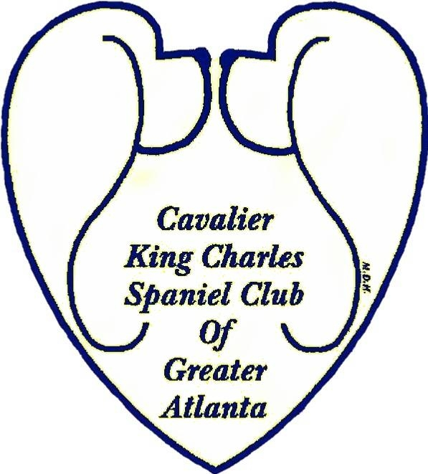

Don’t Miss Our Next Meeting

7:30 PM
October 7, 2008

President’s Message
Congratulations Members!! “We did good!” At our September meeting we had approximately 30 members present. Some of these, we had not seen in quite a while. Please keep it up! The Club needs your support in attendance!
Although we only have three more months of 2008, we still have lots of plans for the club.
There is a Puppy Picnic/Fun Day in the plans for Nov 2. Linda Whitmire has graciously offered to host this at her ball field again. Since we now have the cool fall weather, we should have a great time. Mark your calendars and watch for more information on this.
The Holiday/Christmas Party is another function you don’t want to miss. I believe this is being planned for Dec 14 at Maggiano’s Italian Restaurant. Vickie Herring and Mark Fitchpatrick are busy finalizing these plans. Mark your calendar for this also. There will be more information forthcoming.
One other thing to think about is the upcoming election. At our October meeting the board will select a Nominating Committee which will include one board member and two regular members plus two alternates. If you are interested in being on this committee let one of the board or officers know.
Also let someone know if you are a regular member and are interested in holding an office position or board position.
Again, I was excited to see so many at our September meeting, let’s keep this going and I will see everyone at the October meeting at Marlow’s at the Doubletree Hotel (see information on page 4).
Sincerely,
Alice Alford, President CKCSCGA

Officers and Directors

President:
Alice Alford
Hme: 706-468-2595
Fax: 706-468-0527
JONBOY5@msn.com
Vice President:
Paula Ayers
Hme: 706-342-3292
Cell: 770-597-4138
playerscav@aol.com
Secretary:
Sue Hardwick
Hme: 404-624-9097
shardwi@bellsouth.net
Treasurer:
Vickie Herring
Hme: 678-284-0086
Fax: 678-565-6929
ckcscga@aol.com
Board Members:
Sonya Thompson
Hme: 770-463-3753
Kingswaycavalier@aol.com

Linda Whitmire
Hme: 770-929-0234
bandbmarine@bellsouth.net

Kay-C Phipps
Hme: 770-987-8696
Okay111@bellsouth.net

CKCSCGA Regular Meeting Tuesday September 9, 2008

Minutes

The meeting was called to order at 7:35 pm by Alice Alford.

Members Attending:
Alice Alford, Marlene Anderson, Paula Ayers, Missy Crane, Jeff Herring, Vickie Herring, Kay-C Phipps, Sonya Thompson, Linda Whitmire, Mark Fitchpatrick, Holly Majka, Lee Chenevert, John Chenevert, Jody Floyd, Rita Guest, John Guest
Carol Land, Hollis Land, Wesley Sherrill, Hilarie Gibbs-Sykes

Guests Attending:
Ashley Powell, Ginger Clark, Larry Crane, Cheryl Rhodes

Welcome Guests:
Alice and the membership welcomed guests Ashley Powell, Ginger Clark, Larry Crane, and Cheryl Rhodes.

The June Regular Minutes were published in email. Kay-C Phipps motioned that the minutes be accepted. Vickie Herring seconded the motion. All Approved.

Report of President
The Puppy Picnic will be held on November 2nd at Linda and Bart Whitmire’s house/baseball field in Conyers. They will set up a mock AKC ring and mini-conformation and handling classes will be held. Anyone who would like to serve on the committee or has any suggestions, please contact Alice or Linda.

It is time to begin planning for the CKCSCGA Holiday Party. We have several options. Carolyn Powell volunteered her home, Maggiano’s or the Marlow’s Tavern at the Doubletree Hotel. Mark Fitchpatrick will check to see availability for the restaurants.

Report of Secretary
Correspondence: There has been no correspondence to the club since the July meeting.

Membership Applications: Second Readings: Anne James; First Readings: Ashley Powell (Junior Application), Ginger Clark
(cont. next page)

Report of Treasurer:
Vickie Herring presented the Treasurer’s report. Our Total Balance as of September 9, 2008, is $21,871.95 with monies held in Reserve for the Health and Education Fund of $3,944.14. Total expenses were $1,215.08 and the Trophy Fund of -$147.51, resulting in a General Fund balance of $18,075.32.

Supported Entry:
Vickie Herring provided an update on the All Hallows Eve Cluster. The Premium is on Onofrio now and closes on October 8, 2008.

Committee Reports
Show Committee: Alice Alford reported that everything is on schedule. There will be a meeting in November for all Show Committee members.

Trophy Committee: Sonya Thompson reported that she, Alice Alford, Paula Ayers, and Brenda Martz have ordered trophies. The vendor gave a 40% discount. Items such as a Quilt, Hand Towels, and Grooming Bags were ordered. Members will be receiving a letter from Sonya requesting donations for the Trophy fund.

Auction Committee:
Alice Alford provided an update and everything is on schedule and members Sue Hardwick and Holly Majka met several times throughout the summer to plan. Anyone who would like to donate auction items should see Sue Hardwick. The auction and banquet will be held at the same place as last year, though the hotel is now called the Ramada Airport Convention Center

Website/Publicity: At the end of September, the CKCSCGA website will be run by Sonya Thompson. It is presently run by Roxy Hayes.

Unfinished Business
None.

New Business
Anne James was approved as a new Associate Member.

Adjournment
Jeff Herring motioned to adjourn the meeting at 8:11 pm. Beth Arenburg Seconded. All Approved

Submitted by Holly Majka (fill-in for Sue Hardwick, CKCSCGA Secretary)

Calendar

10/07/08: CKCSC of Greater Atlanta Meeting
6:00 Board Meeting (open to membership)
7:30 PM Meeting - Please plan to attend
NOTE: new meeting site Marlows
4156 La Vista Road,Atlanta, GA 30084
For Directions: 678-987-1197
http://www.marlowstavern.com/locations

10/25/08 Marietta, GA
Kennesaw Kennel Club, Inc
Heart (Jacobs) auscultation $30.00
From 9:30 am - 4:00 pm..
FOR INFORMATION OR TO PRE-REGISTER
Contact: Pat Wahl, telephone 770-713-2256
gcpfoods@comcast.net
and
The Cocker Spaniel Specialty Club of Ga
Eyes (Martin) CERF $28.00
From 9:00 A.M. to 5:00 P.M.
No appointments, first come, first served
Contact: Deborah Torras djtlaw1@juno.com
Jim R Miller Park, 2245 Callaway Rd. SW, Marietta, GA 30008

10/25/2008 & 10/26/2008
CKCSCGA Supported entry
All Hallows Eve Cluster
Marietta, GA www.infodog.com

10/26/08 Marietta, GA
MICROCHIP CLINIC
The Humane Society of Cobb County
All Hallows Eve Cluster
10:00 A.M. - 2:00 P.M.
COST: One Dog - $40.00, Two Dogs - $35.00 Each, Three or More Dogs - $32.00 Each
Registration is included. (The Clinic will be located in the pod area of the show grounds.)
Please Call & give name, phone number, number of dogs you will be bringing
Contact: Joy Evilsizor, 770-428-9882

11/02/08 Conyers, GA
CKCSCGA Fall Puppy Picnic
Contact: Linda Whitmire
bandbmarine@bellsouth.net

CKCSCGA Regular Meeting

Tuesday October 7, 2008

Agenda

Call meeting to order at 7:30pm
Welcome visitors
Minutes of September meeting
Report of President
Report of Secretary
Report of Treasurer
Committee's Report
1. Fun day/ Puppy picnic
2. Holiday/Christmas Party
3. Judges Committee
4. By laws Committee
5. 2009 Specialty Committee
6. Website
Unfinished Business
1. Meet the Breed at Miller Park
New Business
1. Announce the Nominating Commmittee
Adjournment
Braggs

Note from the Secretary: We have a lot of business to transact at the upcoming meeting, including appointment of the nominating committee. It is important that we have a quorum and that members arrive on time.

****New Meeting Site – Marlows****
4156 La Vista Road,Atlanta, GA 30084
For Directions: 678-987-1197
http://www.marlowstavern.com/locations

Note: Please e-mail Alice at jonboy5@msn.com if you are planning to attend the upcoming meeting on October 7, 2008

CKCSCGA Welcomes New Members

We welcome Ann James as a new associate member

Standing committees
Program Committee Sue Hardwick, Chair
shardwi@bellsouth.net

Education /Publicity Committee Sue
Hardwick, Chair shardwi@bellsouth.net
Rescue Committee Sonya Thompson, Chair Carol Quaif, assistant. kingswaycavalier@aol.com
Show Committee We will be looking for volunteers for our 2009 Specialty Contact Alice if you are interested Jonboy5@msn.com
Judges Selection Committee Paula Ayers, Chair playerscav@aol.com
Newsletter…..Hilarie Gibbs-Sykes Locustlee@yahoo.com
Sunshine Committee….Maureen Miles 770-460-9197 mvmiles@bellsouth.net

As always, if you have any ideas for programs, or suggestions to help make our club more successful, please don’t hesitate to contact any officer, board member or committee member.



Brags

Jennifer Wehking, St Jon

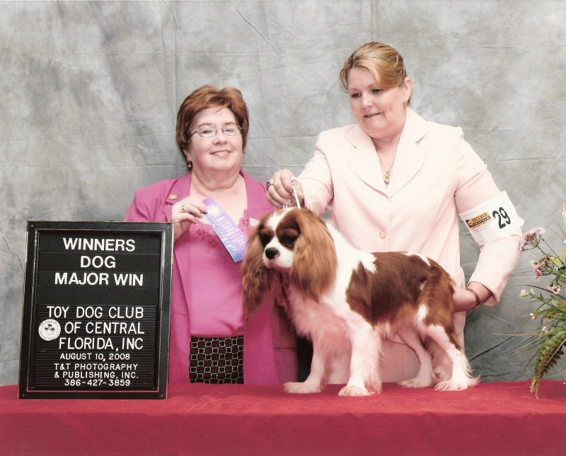

St Jon Ticket To Ride - Winners Dog (major), Toy Dog Club of Central Florida

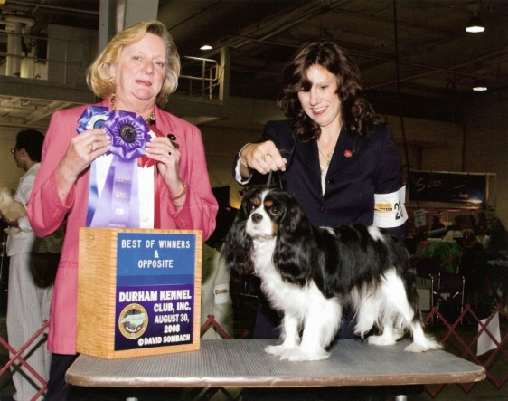

Ch St Jon Jamcroft Myki Likes It - BOW and BOS,
Durham Kennel Club

Marlene Anderson, Castlekeep

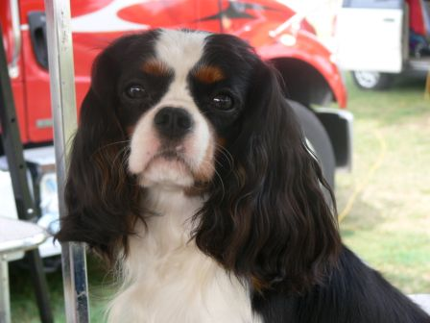

Charterwood Dashing – Winners Dog (major) & BOW
Cape Cod Kennel Club

Pat Lander, Jayba:

Cinderlace Bramble At Jayba was Winners Dog and Best of Winners for a 5 Pt Major at the first independent Central Carolina CKCSC Speciality Sept 12 under UK judge Veronica Hull. Bramble also was RWD to a 5 point Major the same weekend.

Loranka's Enchanted Evening At Jayba was WD and Best of Winners for a 5 pt Major in Greenville South Carolina

.Terri Easterbrooks, Rock Cliff Farm

AKC CH Rock Cliff Farm Double Bless'd (Ch Pascavale Double Take x RCF Bella Luna) Finshed going Best of Breed at Lockport, NY

Kibbles 'N' Bits

Club Contacts:

SUNSHINE: If anyone knows of a member who has been ill, suffered a lost in their family, celebrated a birth or marriage, etc. or just needs cheering from the club please notify Maureen Miles at 770-460-9197 or mvmiles@bellsouth.net .

CONTACT INFORMATION: If you have a change in address, phone number, or email address please notify Sue Hardwick at shardwi@bellsouth.net or Vickie Herring at ckcscga@aol.com .

BREEDER REFERRAL: Send changes, corrections, or additions to your breeder referral listing on the club’s website to Vickie Herring at ckcscga@aol.com Also contact Vickie if you would like to be included in the Breeder Referral listings.

FIND US ONLINE FOR ALL THE LATEST NEWS AT: www.ckcscatlanta.org
If at anytime you have questions, suggestions or concerns regarding the CKCSCGA please contact any of your officers or board members – WE WANT TO HEAR FROM YOU!

WatchDog:

Georgia Coalition of Dog Clubs, Inc. click on 2008 Legislative Summary
This is a watchdog group which the club supports. Given the ever increasing anti-breeder legislation that is happening on a nationwide basis, we all need to stay informed. Keep up with what is happening in Georgia by visiting this site

Editor's Corner

Interesting Books

“The Story of Edward Sawtelle”
David Wroblewski.
An Oprah Book Club selection. Story of a mute boy growing up in Wisconsin in a multi-generational family whose avocation is dog breeding. Highly recommended by many reviewers.

“SOS DOG The Purebred Dog Hobby Re-examined”
Johan and Edith Gallant
The authors examined the lives of African village dogs. What they saw was an indigenous South African canine society that is so healthy, well adjusted and mentally sound that it caused them to question their lifetime of experience with purebreds.
Deadlines:

Deadline for submission for the September newsletter is October 18, 2008. Send articles, brags, litter announcements and advertisements to me at locustlee@yahoo.com There is no charge for member advertising. If you have suggestions for articles or find a website that others might enjoy, please let me know. You can also reach me at 865-988-5271. Thank you. Hilarie Gibbs-Sykes

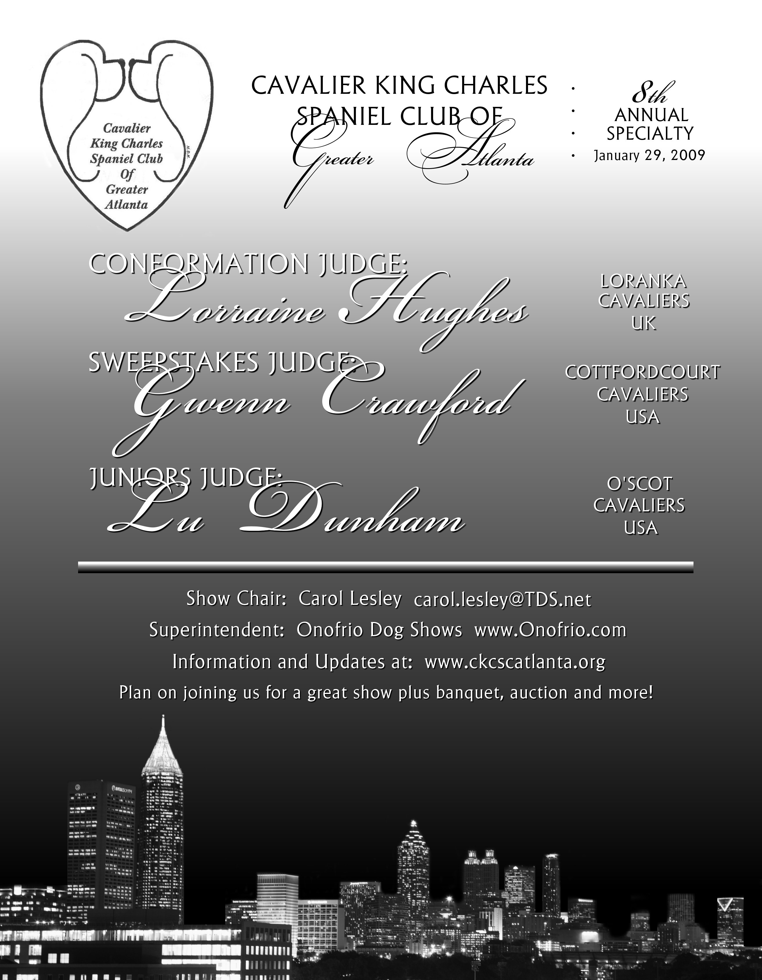

2009 ACKCSC NATIONAL SPECIALTY SHOW

Hyannis, Cape Cod, Massachusetts
APRIL 27-30 (Mon -Thurs)
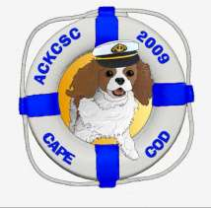
Futurity - John Gammon - Mon
Sweepstakes - Patty Kanan - Mon
Obedience & Rally - Elizabeth Chase – Tues & Wed
Conformation - Dogs - Elaine Lessig- Tues
Junior Showmanship - Elaine Lessig- Tues
Conformation - Bitches - Kenneth McDermott - Wed
B.O.B. - Intersex - Kenneth McDermott - Thurs
Followed By:

1ST CSNE SPECIALTY (AKC APPROVAL PENDING) MAY 1-3 (Fri – Sat)

SAWNEE MOUNTAIN KENNEL CLUB OF GEORGIA INC

AKC SANCTIONED B/OB/Rally Match
CGC (Canine Good Citizen Test Offered)

Saturday, October 11TH, 2008
Conformation, Obedience and Rally
For more information go to:
http://www.smkcga.com/matches.htm

Central Park, 2300 Keith Bridge Rd. (GA State Road 306), Cumming, Georgia 30040

Mark your Calendars!

We are looking forward to the 2nd Annual Fall Puppy Picnic being held on Sunday, November 2 at 11:00 am. Bart and Linda Whitmire have once again graciously offered us the use of their beautiful acreage out in Conyers. The past three picnics have been a huge success and lots of fun, and we anticipate the same at this one.
There will be a Potluck Side Dish/Dessert with the Club providing hot dogs, hamburgers and soft drinks. Members are invited to bring their puppies for evaluation, socialization, training and awards such as Wild Child and Best Kisser!
We are looking forward to another great Picnic at the Whitmire “Field of Dreams”!
Watch for the eVite invitation email coming soon.



